**Tutorial 4: Data Link Layer (OSI Model)**

**Q1**

1. Give a term that related to upper sublayer of layer two and briefly describe that term.(3 marks)

* Logical Link Control sublayer
* Description LLC sublayer
* Defined by IEEE 802.2
* Communicates between the software at upper layer and hardware at lower layer
* It places information in the frame that identifies which network layer protocol has been used
* These information allows multiple layer 3 protocol (IPv4 or IPv6) to use the same network interface and medium
* It takes network layer protocol and put control information to help deliver the packet to destination

1. The following figure shows a frame of the data link layer.

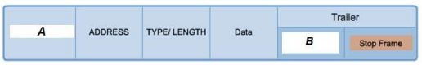

*Figure 1: A structure of a frame*

(i) Identify a header of a frame that is labeled as “A” from Figure 1 and state the function of that

flag. (2 marks)

* **A:** Start frame
* It is used to identify the beginning of the frame

(ii) Based on Figure 1, identify a frame trailer that had indicated as “B”. List the role of that flag.

(2 marks)

* **B:** Frame Check Sequence(FCS)
* It performs error detection

1. Protocol Data Unit (PDU) of a message in the Data Link Layer is called frame. A frame consists of three portions. They are referred to as header, data and trailer.

(i) Identify a sublayer of Data Link Layer that defines the media access processes performed by the hardware. (1 mark)

* Media Access Control (MAC) Sublayer

(ii) Identify and briefly describe TWO (2) fields that are related to the header of a frame.

(6 marks)

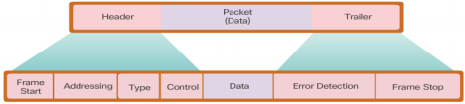

* **Frame start** – Used by the MAC sublayer to identify the beginning of the frame.
* **Addressing** – Indicate the source and destination nodes in the media. (MAC Address)
* **Type** – Identifies the Layer 3 protocol in the data field
* **Control** – Identifies special flow control services such as quality of service (QoS).

(iii) What is the purpose of a stop frame located at the trailer of a frame? (2 marks)

* It indicates the end of the frame when transmitted.

**Q2**

The Figure 2 shows a network topology on how computers can communicate across LAN and WAN via different types of physical media and Layer 2 protocols. Answer the following question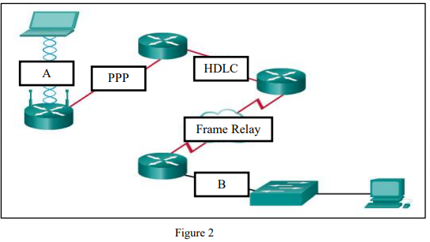

(i) “A” and “B” are two different popular network connection methods for LAN. Identify the type of connecting media and the IEEE Networking Standard of LAN “A” and “B” respectively. (4 marks)

| **Label** | **Connecting media** | **IEEE Networking Standard** |
| --- | --- | --- |
| A | Wireless media | 802.11 Wireless LAN |
| B | Copper cable | 802.3 Ethernet |

(ii) There are two types of access methods in LAN topology. Which access method is used for both “A”

and “B”? (1 mark)

* Contention-Based Access

(b) If the data link layer didn’t exist, what changes would be required of a network layer protocol such as

Internet Protocol (IP)? (6 marks)

* Without a data link layer,IP or other network layer protocols would need to make provisions for connecting every type of media that could exist along the delivery path.
* Moreover, IP would need to change every time a new network technology or medium were developed
* The disadvantage is avoided by using a layered model for networking and by giving the data link layer the job of placing data on a medium and controlling access to the medium.